Remote education provision: information for parents
This information is intended to provide clarity and transparency to students and parents or carers about what to expect from remote education while schools or bubbles remain in lockdown.
For details of what to expect where individual students are self-isolating, please see the final section of this page.
The remote curriculum: what is taught to students at home
This will depend upon whether it is an individual student, a small group, a year group or whether it is the whole school which has been sent home to isolate.
With remote education, will my child be taught broadly the same curriculum as they would if they were in school?
  - As far is possible, we teach the same curriculum remotely as we do in school. For some subjects, the content will be the same, with adaptations only for content delivery.
  - For practical subjects such as Drama, Music, Art and Design and Technology, there may be some adaptations made to the curriculum or changes in the sequencing of curriculum delivery to accommodate remote learning. Curriculum content was considered carefully at the start of this academic year and adaptations made to ensure the best provision for students in the event of lockdown.
Tutor Time
Pastoral provision is extremely important to Ormiston Park Academy so students will be provided with the following between 8.45 and 9am on the following days:

Monday 8.45 – 9am Tutor group so discuss the previous week.
Wednesday 8.45 – 9am Assembly with Heads of Year, Tutors and SLT links.
Friday 8.45 – 9am Tutor group check in with students.

Tutors and Heads of Year will not only use these sessions to share activities for the week but will also carry out well-being checks on students and answer any questions students may have. Please note that tutor sessions are compulsory.

Years 7, 8 and 9
  - Years 7, 8 and 9 will receive on-line learning for their full timetable using Microsoft Teams by their classroom teacher.
  - Lessons will be 40 minutes long, g, but students will be provided with work to utilise the whole hour.
  - Students should submit work via Teams, complete notebook work if provided for the lesson and ensure assignments set during lesson time or for homework are completed in line with normal school policies.
  - Lessons are recorded and uploaded onto Teams for students to be able to catch up if required.
  - Lesson content will follow the programme of study outlined within each Department’s curriculum plan.
  - Students will receive homework as normal which will be set on Satchel One in line with student’s timetables. It is expected that homework will be completed.

Years 10 and 11
  - Years 10 and 11 will receive all live lessons in line with their timetables.
  - Students are expected to join and fully engage in every lesson.
  - They are required to submit their completed work at the end of each lesson.
  - Live lessons will be 40 minutes long, but students will be provided with work to utilise the whole hour.
  - In the case of double lessons, students will be taught for the first lesson, then have independent work set for the second part of the lesson which should be submitted by the end of the lesson for the teacher to assess.
  - Students will be set homework as normal which might be an assignment or work on teams, flipped learning, GCSEpod or independent learning. Whatever is set, students and parents will be informed via Satchel One (Show my Homework).

Remote teaching and study time each day
How long can I expect work set by the school to take my child each day?
  - We expect that remote education will be in line with student’s ordinary school day, consisting of 6 lessons on Monday and 5 lessons Tuesday to Friday.
  - Each lesson will be taught for 40 minutes but tasks and learning will take up to the hour for students.
Accessing remote education
How will my child access any online remote education you are providing?
  - Students will be receiving their lessons using Microsoft Teams.
  - Teachers will invite students to lessons which correspond to their normal timetable.
  - Invites should appear on their Teams calendars.
  - Homework may be set on Teams using assignments but will be uploaded onto Satchel One (Show My Homework) so that parents will remain informed of the work being set.
  - For those students in Years 10 and 11, some of the homework set will be from GCSEpod which is a revision tool proven to improve student achievement in GCSE subjects. Again, this information will be conveyed via Satchel One.

If my child does not have digital or online access at home, how will you support them to access remote education?
We recognise that some students may not have suitable online access at home. We have already taken the following approaches to support students to access remote education:
  - We have provided nearly 100 laptops to students who would not have been able to access the internet otherwise. Information about this has been provided via communication from the school and has been posted on social media.
  - Paper learning packs have been provided where needed to ensure all students can access the curriculum. These can be returned via post or left a reception for teachers to access at a pre-arranged time.
  - School provision caters for those students where one parent is a key worker, where a student is deemed vulnerable, has an EHCP, or where being in school will be beneficial to the education of the student.
  - Full time face to face teaching is provided for students in ASCEND.

If your child does not have access to a device at home for their remote learning, please contact Dkelly@ormistonpark.org.uk

If you have any other issues, they please contact the relevant Head of Year

Year 7 – Mrs Fenton-Hawes is lhawes@ormistonpark.org.uk
Year 8 – Ms Mussenden is smussenden@ormistonpark.org.uk
Year 9 – Mr Nicorici is fnicorici@ormistonpark.org.uk
Year 10 – Ms Berry is cberry@ormistonpark.org.uk
Year 11 – Ms Nkallo is cnkallo@ormistonpark.org.uk

If your child has a device but is struggling to access their remote learning, please contact OPARLSupport@ormistonpark.org.uk

  - Students with limited IT access can request paper packs/workbooks which can be collected from the academy by arrangement with the Head of Year or member of the pastoral team.
  - Completed work can be submitted via reception at a prearranged time.

Engagement and feedback
What are your expectations for my child’s engagement and the support that we as parents and carers should provide at home?

Expectations of Students
  - It is expected that students are contactable during the day
  - It is expected that students attend every lesson on time
  - It is expected that students remain engaged and focused in the lesson, partaking in discussions and answering when required
  - It is expected that students only unmute themselves when asked to answer a question and do not try to disrupt lessons.
  - It is expected that the chat function is used solely for the benefit of learning and that all comments are suitable for the content being studied.
  - It is expected that students complete all tasks set, either within the lesson or set as homework and that this work is uploaded onto Teams.
  - Where work is unable to be submitted by Teams, students can upload via Satchel One, email the teacher or submit via reception.
  - Students should seek help if needed, from teachers or teaching assistants and alert teachers if they are not able to complete work.
  - It is compulsory that all students attend their Monday and Friday tutor session and their Year group assembly on Wednesdays.

Expectations of Parents
We value the support given by parents/carers to their children when working remotely.
  - Please try to ensure students remain in a routine to ensure consistency
  - Please try to ensure that students are up and ready to learn in time for each of their lessons
  - Please try to ensure that students engage in the lesson and undertake activities set to ensure their learning and understanding
  - Please try to ensure that assignments and Homeworks are completed and submitted
  - Please support teachers in working with your child to achieve the best possible education for them
  - Please try to ensure students get enough sleep, have a healthy diet, get some fresh air and exercise for their own well-being.
  - We ask that parents/carers make the school aware if their child is sick or otherwise cannot complete work.
  - Please contact your son/daughters tutor, heads of year or teacher if there are any problems or issues with which we can help. This may relate to either on-line lessons, or their well-being.
How will you check whether my child is engaging with their work and how will I be informed if there are concerns?
  - Registers will be taken every lesson to ensure attendance.
  - Parents will be informed via Behaviour Watch should a student fail to attend a lesson
  - Engagement will be assessed during the lesson by the teacher asking questions to check understanding, setting short tasks and assignments or quizzes on Teams.
  - Students should be submitting at least one piece of work every lesson so teachers can check understanding of content and skills prior to moving on.
  - Should students fail to answer questions either verbally or on the chat, fail to complete tasks or submit assignments or complete quizzes, parents/carers will be notified via Behaviour Watch, e-mail or phone call.
  - Where there is a concern around the level of student engagement, parent/carers will be contacted to assess whether school intervention can assist engagement.
Remote education for self-isolating pupils
Where individual students need to self-isolate but the majority of their peer group remains in school, how remote education is provided will likely differ from the approach for whole groups. This is due to the challenges of teaching students both at home and in school.
  - Hopefully, with the introduction of Lateral Flow Testing, disruption due to self-isolating will be minimized once back at school.
  - Students who are self-isolating will have access to all resources. Power Points and any worksheets will be uploaded onto Teams and Satchel One (Show my Homework). This will mean that they will be able to complete all activities and can submit work via Teams or Satchel One.
  - Resources will include Do Now’s to help retrieval practice, stretch and challenge tasks and be in line with the content of the National Curriculum.
  - All classwork and homework will continue to be marked in line with the school policy and with the rest of the class as long as it is submitted to the teacher.

The Academy Assessment and Reporting Calendar

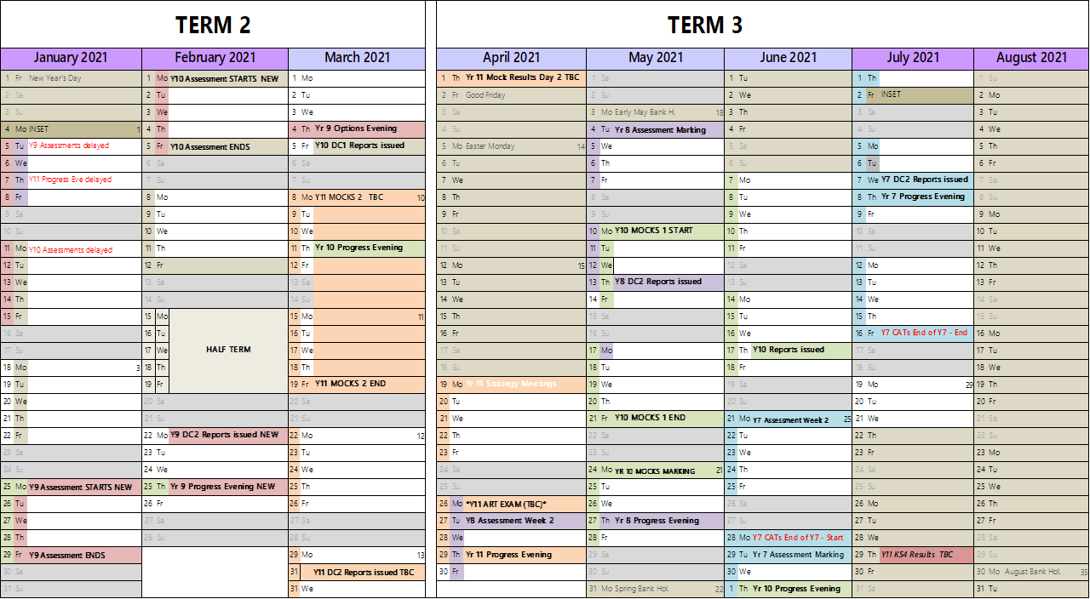

Should you have any queries regarding assessment and reporting, please contact Mrs Thacker (Assistant Principal) sthacker@ormistonpark.org.uk

Additional support for students with particular needs
How will you work with me to help my child who needs additional support from adults at home to access remote education?
We recognise that some students, for example some students with special educational needs and disabilities (SEND), may not be able to access remote education without support from adults at home. We acknowledge the difficulties this may place on families, and we will work with parents and carers to support those students in the following ways:

- As recommended in the SEND Code of Practice, quality first teaching must be the first line response for students both with and without special educational needs, and this continues to be a priority for all teaching and learning at Ormiston Park Academy.
- Class teachers will be differentiating for the students in their lessons, by providing adjusted tasks and activities for their students, to ensure all students with special educational needs can access their learning in-line with their peers. Please make us aware if further support in any of your child's subjects is required.
- Class teachers will continue to differentiate the homework tasks they are setting for their classes on Show My Homework, so that all students with special educational needs can learn in-line with their peers.
- Additional training materials focusing on techniques and strategies to differentiate for students, with special educational needs during remote learning, has been shared with all teaching staff at the academy.
- Members of the Senior Leadership Team continue to the observe remote learning in Teams lessons across all subjects, and monitor differentiation for the students within each class, providing feedback to class teachers and curriculum leaders.

