Ormiston Academies Trust

Behaviour policy
Date adopted: January 2019 Next review date: January 2022

Policy version control
Policy type | Statutory
Author | Sarah Bloomer – Head of Safeguarding
Approved by | Paula Arrowsmith, November 2018
Release date | December 2018
Next release date | December 2021
Description of changes | No changes

Contents
- Policy statement and principles page 3
- Definition page 3
- Complaints page 4
- Monitoring and review page 4
- Roles and responsibilities page 4
- Academy behaviour page 7
- Classroom behaviour page 8
- Attendance page 8
- Uniform and appearance page 9
- Unacceptable Behaviour page 9
- Drugs page 10
- Alcohol page 10
- Disciplinary Sanctions page 11
- Regulating students’ offsite conduct page 12
- Unacceptable behaviour outside the academy page 12
- Rewards Policy page 13

- Policy statement and principles
We are dedicated to ensuring that our academy environment supports learning and the wellbeing of students and staff through a strong sense of community cohesion. Cooperation, support, and respect are the foundations of our community and we work hard to provide a safe academy where students feel included in every aspect of academy life and comfortable to voice their opinions.
Ormiston Park Academy embeds British values across the curriculum and throughout students everyday life at the Academy. The embedding of this allows for our students to have amongst other qualities a strong moral purpose, re-assess their learning vision and philosophy, develop resilience and safeguard themselves against all forms of extremism.

This policy outlines what we expect from all our students in terms of their behaviour, and the sanctions that will be enforced if this policy is not adhered to. It extends to all members of our academy community. Good behaviour and self-discipline have strong links to effective learning and are vital for students to carry with them both during and after their academy years.
We believe that all students should be aware of the standards of behaviour that are expected of them and take responsibility for promoting these standards. We hope that by encouraging positive behaviour patterns we can promote good relationships throughout the academy built on trust and understanding, and that through the use of this policy we can support all of our students in developing a high level of social awareness. Our aim is to ensure that all our students leave the academy with the key skills they need to continue to progress to the best of their ability in all areas of life.
At Ormiston Park students, teachers, support staff and governors aim to create a safe, disciplined and attractive environment in which we:

• Promote outstanding behaviour and discipline

• Feel secure and free from intimidation

• Recognise and develop our capabilities, talents and gifts

• Are confident, caring and responsible

• Take pride in our own and others’ achievements

• Share a genuine desire to improve

• Understand that learning and social development are lifelong experiences

We seek a non-violent and non-aggressive culture for the school and will encourage everyone to deal with conflict peaceably, demonstrating that outstanding behaviour makes outstanding learning.

- Definition

Behaviour for learning is being in a way of thinking that allows you to learn the most in your lessons.

This policy is consistent with all other policies adopted by OAT / the academy and is written in line with current legislation and guidance.
The phrase ‘behaviour for learning’ conceptualises the following three relationships experienced by a student:
- Their relationship with themselves, e.g. their self-confidence as a learner
- Their relationship with others, e.g. how they socially interact
- Their relationship with the curriculum, e.g. how best they learn
In order to foster a positive learning environment in Ormiston Park Academy these relationships must be developed and supported.
Most social, emotional and behavioural skills are learned, with behaviour for learning being a theoretical approach to the learning experience.
Rather than focussing on unwanted behaviours, the behaviour for learning approach puts value on positive behaviours, which enable and maximise learning.
This approach helps students understand the behavioural skills they need, what the teacher wants them to do, and why this will help them to learn.

- Complaints
All complaints are dealt with under the OAT Complaints Policy.
Complaints should be made in writing and will follow the OAT complaint procedures and set timescales. The handling of complaints may be delegated to an appropriate person.
The outcome of the complaint will be communicated in writing.

- Monitoring and review
This policy will be reviewed [insert time period] or in the following circumstances:
- Changes in legislation and / or government guidance
- As a result of any other significant change or event
- In the event that the policy is determined not to be effective
If there are urgent concerns these should be raised to the Director of Business and Finance in the first instance for them to determine whether a review of the policy is required in advance of the review date.

- Roles and responsibilities
Students
The academy expects all of its students to show respect to one another, to academy staff, and anyone else that they may meet. Incidents of bullying, denigration, or bringing intentional harm to other students or staff will not be tolerated.
Students are ambassadors of our academy even when off academy premises, and we expect them to act accordingly. They are expected to obey academy rules, listen, follow instructions by staff, and accept and learn from any sanctions that they receive. This extends to any arrangements put in place to support their behaviour, such as pastoral support programmes or parenting contracts.
Academy work and homework should be well presented, completed to a high standard, and handed in on time. Failure to hand in work on time will lead to disciplinary sanctions. If students are struggling to meet the requirements of their workload for any reason, they should discuss this with their tutor who will work with them to draw up a support plan. The academy asks that students carefully read and then sign the home-academy agreement to show that they have understood what is expected of them and acknowledge the responsibility that they have for their own behaviour.

Students will:
- Abide by the Home-Academy Agreement and the Academy’s Behaviour for Learning Policy at all times.
- Act as positive ambassadors and representatives of Ormiston Park Academy through their exemplary behaviour.
- Be polite and respectful of others in the surrounding community.
- Work to the best of their ability and effort at all times, whilst allowing other students to do the same.
- Cooperate with other students and members of staff in order to create a positive learning environment.
- Be ready to learn by ensuring regular attendance to all lessons and arriving at Academy with the correct equipment.
- Correctly present themselves in name of Academy’s uniform, in accordance with the Academy’s Uniform Policy.
- Respect and value the environment and their surroundings, as well as each other.
- Not act in a manner which is disruptive to the learning of others.
- Under no circumstances put the health and safety of others at risk.

Academy
The academy understands that the first step to modelling good behaviour is to lead by example, which means that all staff, volunteers, and anyone else who comes to the academy must act responsibly and professionally, and will never denigrate students or colleagues. We work hard to ensure that discipline is consistent across the academy so that behaviour boundaries and sanctions are clear to all and are applied fairly, proportionately, and without discrimination, taking into account special educational needs and disabilities as well as the additional challenges that some vulnerable students may face.
Staff are trained to deal with behavioural strategies as part of their continual professional development, and are well informed of the extent of their disciplinary authority.
We work with parents to understand their children and their behaviour and believe that in conjunction with behaviour boundaries and sanctions, good support systems, praise, and rewards for good behaviour are an important part of building an effective learning community.
The academy will report behaviour, good or bad, to parents regularly. We encourage parents to communicate with the academy if they have a concern about their child’s behaviour, and we will do as much as is possible to support parents as and when they need it. We promote good behaviour within the academy curriculum and reminders of academy rules and expected standards of behaviour are up on walls in classrooms and situated around the academy.
Staff are a constant presence around the academy, before and after the academy day, in-between classes, during breaks in the academy day, and at lunch times, to check that students are using the academy grounds respectfully and behaving appropriately.
The academy will take all reasonable measures to ensure the safety and wellbeing of all students and staff and this includes protection from bullying. We aim to combat bullying and other harmful behaviour using, amongst others, preventative strategies through the active development of students’ social, emotional and behavioural skills.

Staff members will:
- Implement the Academy’s Behaviour for Learning Policy at all times.
- Maintain a positive and well-managed learning environment.
- Be positive ambassadors of the Academy at all times, through their professional behaviour and conduct.
- Use the Academy’s reward system and hierarchy of sanctions to promote good behaviour.
- Use the rules and consequences outlined in this policy clearly and consistently.
- Treat all students fairly and equally, seeking to raise their self-esteem and develop to their full potential.
- Undertake comprehensive planning to provide challenging, interesting and relevant lessons, which are appropriate to the age, ability and individual needs of students.
- Record all behavioural events, both positive and negative, on the Academy’s management information system, by following the correct reporting procedure.
- Raise any concerns regarding students’ behaviour with the relevant Head of Year/Pastoral Lead.
- Take the necessary steps to effectively manage student behaviour, such as placing students on report where appropriate.
- Support other members of staff with behavioural issues involving individual students or groups of students.
- Liaise with other members of staff and the senior leadership team (SLT) in order to implement effective behaviour management.
- Organise detentions where appropriate.
- Intervene promptly when they encounter poor behaviour or unexplained absence.
- Immediately contact the Principal and the rest of the SLT when there has been a serious breach of the Academy’s Code of Conduct.
- Contact parents/carers regarding their child’s behaviour where necessary.
- Continuously keep parents/carers informed of any behavioural management issues concerning their child.
- Act in accordance with the Academy’s Exclusion Policy when dealing with more serious breaches of Academy conduct.
- Monitor the attitude, effort and quality of the students’ work.
- Make referrals to external agencies where necessary, e.g. the behaviour support service.
- Inform the SLT of relevant behaviour data and trends.
- Ensure that all records are kept up-to-date, such as the pastoral register and racist incident log.
- Consistently develop their understanding of behaviour for learning and relevant techniques as part of their CPD.

Parents
Parents play a big part in ensuring that their children are responsible for their own behaviour in academy. We ask that parents sign the home-academy agreement to indicate that they will respect and support the academy’s behaviour policy and the authority of academy staff. Building academy life into a natural routine ensuring that your child is at academy on time, appropriately dressed, rested, and equipped will encourage your child to adhere to academy rules and procedures.
We ask parents to work with the academy in support of their child’s learning, which includes informing the academy of any special educational needs or personal factors that may result in their child displaying unexpected behaviour. We ask that parents be prepared to attend meetings at the academy with staff or the principal to discuss their child’s behaviour and to adhere to any parenting contracts put in place.
In the case of exclusions, we ask that parents provide appropriate supervision for their child during the time that they are excluded from the academy and, if invited, to attend a reintegration interview at the academy with their child.

Parents/Carers will:
- Abide by the Home-Academy Agreement, ensuring the attendance and punctuality of their child, as well as reporting any absences.
- Encourage good behaviour and for their child to be an ambassador of the Academy at all times, in line with the Behaviour for Learning Policy, by reinforcing Academy rules.
- Share any concerns they have regarding their child’s education, welfare, behaviour and life at name of Academy with the
- student’s classroom teacher or SLT.
- Support their child’s independent learning.
- Support the Academy’s decisions in relation to behavioural issues, whilst having the right to question name of Academy’s decisions regarding their child’s behaviour.
- Ensure that their child correctly presents themselves as a student of name of Academy, in accordance with the Academy’s Uniform Policy.

- Academy behaviour
Academy rules that apply at all times to all members of the academy community are detailed below. All of these rules also apply when travelling to and from the academy.
- Always be on time
- Keep your appearance smart and tidy
- Wear regulation academy uniform at all times to and from academy
- Rude, derogatory, racist or defamatory language will not be tolerated
- Be considerate of your peers and the extended community
- Do not run through hallways and corridors
- Do not shout out during lessons, or shout to one another in hallways, or when in public places
- Be polite and respectful at all times
- Respect and look after the academy premises and environment, both on the academy site and outside
- Do not litter or not vandalise academy property in any way
- Unauthorised absence from academy will not be tolerated
- Health and safety equipment is only for use in emergency situations and should not be tampered with under any circumstances
- Disobeying staff will not be tolerated
- Under no circumstances will illegal or inappropriate items be brought into academy
- Gambling is not allowed on academy property
The following items are not allowed in the academy under any circumstances:
- Alcohol and drugs
- Cigarettes, matches, and lighters
- Chewing gum
- Weapons of any kind
- Material that is inappropriate or illegal for children to have; such as racist, radical / extremist or pornographic material

- Classroom behaviour
Negative consequences will always result from behaviour that interferes with the student’s right to learn and a teacher’s right to teach.

- A set of the Academy rules will be clearly displayed in each classroom.
- Dealing with behavioural problems is primarily the responsibility of teaching staff.
- Teaching staff will use seating plans and a range of de-escalation techniques to encourage good behaviour and create an effective learning environment.
- Praise will be used to set high expectations at the start of the lesson, in conjunction with non-verbal cues and private corrections in order to focus students on learning.
- Lessons will be structured and have a focussed framework, in order to allow students to understand what is being taught and how it links to what they already know.
- All staff members will support students’ emotional wellbeing and welfare within the learning environment by encouraging students to develop effective social relationships.
- When a student acts in a disruptive manner or ignores instructions given by a staff member, the following three steps will be taken:
    - Reminder – the student is reminded of their expectations
    - Restorative detention – the staff member informs the student of the consequences of their disruptive behaviour, such as issuing a warning of a detention
    - Removal – if the student’s behaviour persists, the staff member will move the student from where they are sat in the classroom, or remove the student from the class, in order to avoid affecting the learning experience of other students
- Staff members will remind students that at each stage of the process they have the opportunity to amend their behaviour, rather than escalate it.
- De-escalation techniques will be used at all times.
- Where poor behaviour continues and intervention is necessary, a three-stage progressive intervention process will be followed:
    - Stage 1 – the classroom teacher will manage behaviour strategies, sanctions and the three-step process outlined above.
    - Stage 2 – if poor behaviour persists, pastoral staff will become involved in managing the behavioural incident.
    - Stage 3 – serious breaches of conduct and persistent offenders will be dealt with by the headteacher and the rest of the SLT.
- The overall aim of the structure of lessons is to actively engage students and to develop their learning skills systematically so that their learning becomes increasingly independent.
- Whilst using the academy corridors and surrounding area of the academy building, students will act in a responsible and respectful manner, as would be expected in a classroom.

- Attendance
Regular attendance at the academy is required by law, and we take attendance very seriously
A register is taken daily and at the start of each lesson. Disciplinary action will be taken against any students who are discovered to be truanting or are repeatedly late.
Parents or carers will be contacted to discuss possible reasons for attendance issues and any support systems that could help. More information can be found in the academy’s attendance policy which is published on our website.
- Uniform and appearance
Effective teaching and learning needs proper organisation, and this starts with a smart and tidy appearance which helps to instil discipline and pride in appearance in students, and reduces the risk of distraction in lessons. Please see the Uniform Policy available on our website.
The standard uniform is as follows:
Girls | Boys
School skirt: Mid-Grey, twenty inches long (50 cm) knee- length Skirt or mid-grey tailored business-style trousers. | School trousers: Mid-Grey Trousers, business-style trousers, full length; NOT denim, brushed cotton, stretch material, chinos or ‘jeans style’
Navy Blue Blazer with OPA logo | Navy Blue Blazer with logo
White Shirt and OPA Tie | White Shirt and OPA Tie
Optional: Academy Jumper with logo  PLEASE NOTE: no other jumpers/cardigans permitted | Optional: Academy Jumper with logo  PLEASE NOTE: no other jumpers/cardigans permitted
Plain Neutral or Plain Black Tights, or white socks ( NOT socks and tights together) | Black or white socks
Coats must be plain black, conventional in design and without motif or writing  Leather, suede and denim jackets or brushed cotton hoodies are NOT acceptable | Coats must be plain black, conventional in design and without motif or writing  Leather, suede and denim jackets or brushed cotton hoodies are NOT acceptable
Plain black shoes with very low, wide heels (NOT trainers or plimsolls). Laced shoes must have black laces. | Plain black shoes, NOT trainers or plimsolls. Laced shoes must have black laces.
PE - Girls | PE - Boys
Plain Black Shorts  OPA White Polo Shirt  OPA Blue Fleece  Suitable Trainers | Plain Black Shorts  OPA White Polo Shirt  OPA Blue Fleece  Suitable Trainers

- Hairstyles - Only natural hair colour and tones are allowed. If you are thinking about changing the colour of your hair, speak to a member of the Pastoral Team first to check that it is within the Academy’s expectations. Extreme styles and colours are not acceptable, including shaved or patterned styles.
- Jewellery - One watch and one pair of small, plain ear studs may be worn. NO other body piercing is permitted.
- False Nails - For health and safety reasons false, gel or acrylic nails are not permitted. We accept clear nail varnish. Any students wearing nail varnish other then clear nail varnish will be asked to remove it using nail varnish remover.
- Make-Up – Discreet make-up is allowed, which means we should not easily see the student is wearing make-up. Any students wearing make-up that is obvious will have to remove it using face wipes. False eye-lashes are not permitted and these will need to be removed.
- Hair bands/Ribbons – must be plain black or plain white

The academy uniform should be worn by all students. Students who come in not wearing the correct academy uniform may be sent home to change.

- Unacceptable behaviour
The following behaviour is regarded as completely unacceptable and will result in disciplinary action and possibly exclusion from the academy on a fixed-term or permanent basis. For more information on exclusions, see our exclusion policy. For more information on exclusions, see our Exclusion Policy, available on our website.
- Verbal abuse to staff and others
- Bullying in any form (see the Anti-Bullying Policy)
- Verbal abuse to students
- Physical abuse / attack on staff
- Physical abuse / attack on students
- Indecent behaviour
- Damage to property
- Misuse, possession or supplying illegal drugs or alcohol
- Misuse of other substances
- Theft
- Serious actual or threatened violence against another student or a member of staff
- Sexual abuse or assault
- Carrying an offensive weapon
- Arson
- Persistent defiant behaviour
- Unacceptable behaviour which has previously been reported and for which academy sanctions and other interventions have not been successful in modifying the student’s behaviour
- Drugs
The academy will not tolerate drug use of any sort on academy property or during off-site academy activities (please refer to the Drugs, Alcohol and Tobacco Policy). The academy takes its anti-drugs policy very seriously and will discipline any person found to be in possession of drugs. This includes solvents and any other substance that can be misused or harmful. Students may be permanently excluded if they are found to be involved in drug-related incidents. This includes supplying, possessing, or taking drugs.

Prescription drugs/Controlled Substances
Carrying, supplying or taking prescription drugs illegitimately could result in a permanent exclusion.
Non-prescription drugs
Some over-the-counter drugs can be harmful if misused. We advise that students should not carry these in academy. If they need medication they can go to the academy nurse.
Medication
We are aware that it may be necessary for some students to take medication during the academy day. (Please see the Supporting Students with Medical Needs Policy). Parents should make the academy aware of this in writing as soon as their child starts taking the medication. The academy may request medical evidence prior to administering any medication.

- Alcohol
Consuming, carrying or supplying alcohol is strictly prohibited. Any student involved in any alcohol-related activity may be permanently excluded.
- Disciplinary sanctions
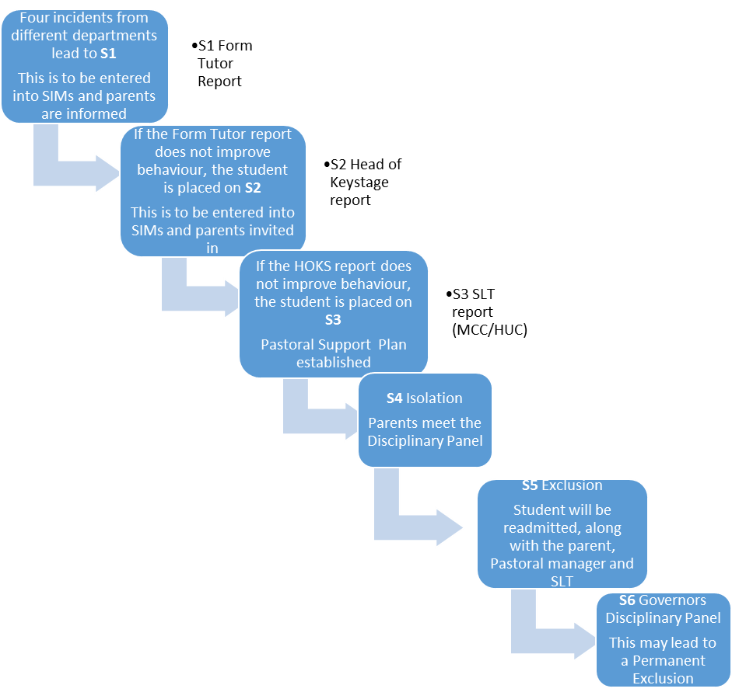
The academy operates using the following disciplinary measures:

Sanctions | Examples of use
Written
Detention
Fixed term exclusions
Permanent exclusions
Searching and confiscation | Staff members are authorised to use confiscation as a disciplinary sanction if it is lawful. This means that staff may confiscate or seize items in the possession of students that are illegal, or banned by the academy. It is our first priority to ensure that students are in a safe and secure environment when they are in our care, and any items that may jeopardise the safety of other students or themselves will be taken off students without notice.  A teacher or someone who has lawful control of the child can search a student with their permission to look for any item that the academy’s rules say must not be brought into academy. Principals and / or members of staff authorised by them have the power to search a student without the student’s consent if they suspect they are in possession of ‘prohibited items’. Prohibited items that can be searched for without consent include:  - Knives or weapons  - Alcohol or drugs  - Stolen items  - Tobacco and cigarette papers  - Fireworks  - Pornographic images  - Articles that have been or could be used to commit an offence or cause harm  - Any item which the academy rules identify as an item for which a search may be made  Staff can seize an electronic device to examine any data or files on the device if they think there is good reason to do so. These data or files may be erased before returning the item if they believe there is good reason to do this.  Where appropriate the items seized may be handed over to the police.  Any cigarettes confiscated in academy will be destroyed.  Following searching and confiscation of items the academy will speak to the parents concerned. Any items confiscated, destroyed or deleted will be recorded by the academy.

Use of force | The academy does not encourage the use of force and it will be used very rarely in special circumstances. There is no definition of when it is reasonable to use force, and every situation will have to be judged by the person in charge at that time. The degree of force used should be the minimum needed to achieve the desired result.  Academy staff can use such force as is reasonable in the circumstances to prevent a student from doing, or continuing to do, any of the following:  - Committing any offence (or, for a student under the age of criminal responsibility, what would be an offence for an older student);  - Causing personal injury to, or damage to the property of, any student (including him or herself)  - Prejudicing the maintenance of good order and discipline at the academy or among any students receiving education at the academy, whether during a teaching session or otherwise  All staff at the academy have the authority to use force when reasonable, and this extends to any other person whom the principal has given the responsibility to be in charge or in control of the students. Staff can also use this power when they are lawfully in charge of students but off the academy premises – i.e. on an academy trip.  Following serious incidents involving the use of force, the academy will speak to the parents concerned. It is up to the academy to decide whether it is an appropriate occasion to report the use of force to parents.  Such serious incidents involving the use of force will also be recorded by the academy.

Sanctions are adapted relating to the seriousness and frequency of the behaviour. Records will be kept of all sanctions imposed upon students for serious misbehaviour.

- Regulating students’ offsite conduct
Students who are caught or known to have been misbehaving on the way to or from the academy, or near the academy premises, will be disciplined by the academy. This also applies to students who break academy conduct during work experience, academy trips, or extended academy activities such as sports events, or any event where poor behaviour might jeopardise the chances of future students participating.
In addition students who seek outside of academy hours to bully or otherwise cause harm to other students at the academy whether through cyber bullying or other ways may be subject to sanctions under the behaviour policy as if their actions had taken place whilst at the academy itself.

- Unacceptable behaviour outside the academy
Community partnership and cohesion is extremely important at Ormiston Park Academy. We expect students to take responsibility for their actions outside of the academy; we also have a legal right to discipline students for misbehaving outside of the Academy premises under Section 89(5) of the Education and Inspections Act 2006.
All unacceptable behaviour and instances of bullying occurring anywhere outside the academy, which have been witnessed by a staff member or reported to the academy, will be dealt with using the academy consequences ladder.
This will include any unacceptable behaviour when a student:
- Is taking part in any activity organized by the academy
- Is travelling to or from the academy
- Is wearing academy uniform
- Is in some other way identifiable as a student at the academy
- Poses a threat to another student or member of the public
- Could adversely affect the reputation of the academy

- Rewards policy
The academy believes that it is important to encourage good conduct throughout the academy by celebrating and rewarding good behaviour.

An aspirational mindset of achievement and progress will be an expectation of staff and student in all lessons and areas of academy life.

Verbal recognition and praise of achievement- staff need to actively seek out opportunities, praise effort and achievement.

Written comments in work books showing positive comments recognising the effort and achievement made will be evident in the academies bespoke exercise books.

Awarding MERIT points to students for excellent effort/progress/attendance/use of learning policies and journals, MERIT points equate to certificate which will be awarded in Assemblies, certificates then act as a ticket to end of year celebration trips. Students will be required to monitor and store

MERIT points and certificates in their learning journals.
Money to be set aside to pay for trips, prizes etc. to recognise excellence across the Academy. Communication with parents via learning journals will be expected weekly, this will be closely monitored by students form tutors.

rewarding good behaviour.

- Ormiston Park Academy recognises that students should be rewarded for displaying consistently good behaviour.
- Praise will be used to help raise student achievement and will be given for progress, not simply for high-quality work.
- Positive behaviour will be promoted and reinforced by the Academy’s clear reward system.
Praise will:
- Be given in relation to a specific task or action.
- Be earned, ensuring that the recipient is clear about what they are being praised for.
- Reinforce name of Academy’s core values and ethos.
- Not be awarded for vague accomplishments or be given too easily and spread too widely.
- Not be in a manner which is selective, exclusive or causes the recipient embarrassment.
- Always have a positive effect upon others as well as the recipient.
- Be used to motivate students and help them to feel valued.

Ormiston Park Academy has a reward system in place which rewards students for displaying good behaviour and progressing their learning.

