Ormiston Academies Trust
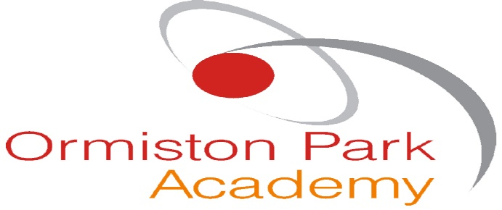

Health and Safety policy
Date adopted: June 2019 Next review date: June 2020

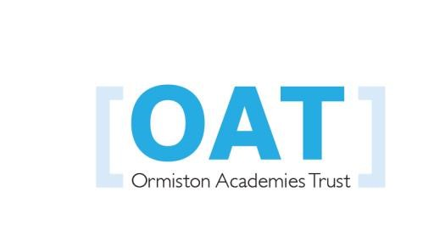
Policy version control
Policy type | Mandatory
Author  In consultation with | Jane Smith
Approved by | Trustees, October 2018
Release date | November 2018
Next release date | November 2019
Description of changes | Changes to the policy include:  Under section 2 this has been changed to Ormiston Academies Trust  Additional responsibilities added to the Responsibility of the Principal  A section added on Responsibilities of a health and safety committee  An additional bullet point on the Responsibilities of an ASO  Under local arrangements - a sentence has been added about OATnet policies  Under section 4.9 - changed the paragraph from ‘equipment’ to ‘work equipment.  Under section 4.13 - added a sentence on Evolve  Under section 5, wording has been added to the Principals signature Flowchart changed around so the Trustees are positioned at the top of the chart  Additional text has been added to the contractors’ section and added to the flowchart

Contents
1. Ormiston Academies Trust Statement of Intent 3
2. Health and Safety Policy 4
3. Responsibilities 4
3.2 Responsibilities of the Governing Body 4
3.3 Responsibilities of the Principal 4
3.4 Duties of the H&S Committee 5
3.5 Duties of the Academy Safety Officer (ASO) 5
3.6 Duties of department heads, supervisors and other managers 5
3.7 Duties of all members of staff 5
3.8 Obligations of contractors 6
3.9 Pupils 6
4. Local Arrangements 6
4.2 Asbestos Management 6
4.3 Water Safety (legionella) 6
4.4 Fire Safety 6
4.5 First Aid 6
4.6 Accident Reporting and Investigation 7
4.7 Risk Assessment 7
4.8 Safe Systems of Work (SSoW) 7
4.9 Work equipment 7
4.10 Hazardous materials 7
4.11 Driving for work 7
4.12 Health 7
4.13 Field trips and other site off activities 8
4.14 Information and Training 8
4.15 Contractors, Visitors and Third parties 8
5. Authorisation 8
Appendix 1 – Current post holders and responsible Individuals 9
Appendix 2 – H&S organisational arrangements (organogram) 10

Ormiston Academies Trust Statement of Intent
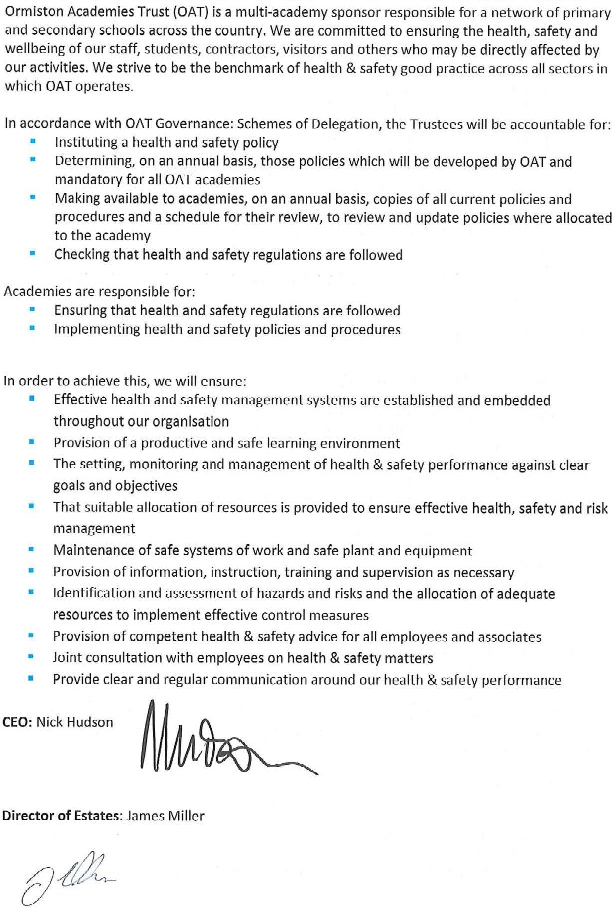

Health and Safety Policy

At Ormiston Academy Trust, each Academy is committed to the health and safety of staff, pupils and visitors. Ensuring the safety of our community is of paramount importance, and this policy reflects our dedication to creating a safe learning environment.
We are committed to:
- Providing a productive and safe learning environment
- Preventing accidents and any work-related illnesses
- Compliance with all statutory requirements
- Minimising risks via assessment and policy
- Providing safe working equipment and ensuring safe working methods
- Including all staff and representatives in health and safety decisions
- Monitoring and reviewing our policies to ensure effectiveness
- Setting high targets and objectives to develop the school’s culture of continuous improvement
- Ensuring adequate welfare facilities are available throughout our school
- Ensuring adequate resources are available to address health and safety issues, so far as is reasonably practicable
- Safe arrangements for the handling, storage and transportation of any articles and substances
- Supervision, training and instruction so that all staff can perform their duties in a healthy and safe manner
- Where necessary, protective equipment and clothing, along with any necessary guidance and instruction

Responsibilities

Responsibilities of the Governing Body
The governing body, in conjunction with the Principal, will:
- Ensure effective communication with Ormiston Academies Trust on matters of health and safety and provide assurances to the trust on a routine basis
- Ensure familiarity with the responsibilities and requirements of any appropriate legislation
- With support from Ormiston Academies Trust, create and monitor a management structure for health and safety in the school
- Ensure the health and safety policy is communicated and is implemented by all.
- Periodically, with assistance from Ormiston Academies Trust, assess the effectiveness of the policy and ensure any necessary changes are made
- Identify key risks relating to possible accidents and injuries, and ensure they are adequately controlled, as to prevent them occurring
The governing body must liaise with the Trust’s Health and Safety Officer for the point of contact for dealing with any critical incidents in the region

Responsibilities of the Principal
The Principal has the overall responsibility for the day-to-day development and implementation of safe working practices and conditions for all staff, pupils and visitors. The Principal will designate an Academy Safety Officer (ASO) who will implement day-to-day health and safety practices.

The Principal in conjunction with the governing body, must ensure that:
- Policies relating to evacuation and to the response to critical incidents are in place, in date and communicated within the academy
- Ensure that the Health and safety Policy is communicated to all Heads of departments and other staff members.
- Ensure that they communicate other Health and Safety Policies available on OATnet to all appropriate members of staff.
- Ensure a Health and safety Committee is set up within the Academy. This would include a member of the SLT team (School Leadership Team), a member of the support team and a Teacher.
- Records of medical incidents are kept and are available to view and that a sufficient number of colleagues are first-aid trained
- Security arrangements regarding the academy’s grounds, premises and facilities are fit for purpose
- The Principal must ensure that all accidents, incidents and near misses are recorded, using the on line accident recording system as stated in 4.6

Duties of the H&S Committee

The H&S Committee are tasked with:
- To be involved in the monitoring of health and safety training
- To be involved in the continuous monitoring of arrangements for health and safety
- To look at accidents statistics, ill health for the academy and to monitor and review trends.
- To be involved and assist the ASO with the actions of the health and safety audit reports/Fire risk assessments by ensuring the actions/recommendations of the report is implemented.
- To ensure there is a process in place for reviewing of Risk Assessments.

Duties of the Academy Safety Officer (ASO)
The ASO has delegated authority from the Principal but ultimate responsibility rests with the Principal and board of governors.

The ASO is tasked with:
- Giving sound competent advice to staff, the Principal, the board of governors and others as requested
- Ensuring appropriate permits are used when deemed necessary by the risk assessment
- Ensuring adequate assessment and provision for visitors who may be impacted by our undertakings
- Ensuring adequate assessment, provision and cooperation with contractors, as to minimise the risks
- Assisting others in the production of suitable and sufficient risk assessments
- Ensuring adequate assessment and authorisation for fieldwork and trips is made in advance
- Ensuring that accidents and incidents are appropriately recorded and investigated
- Providing regular benchmarking and assurance on the status and provision of health and safety within the school to the headteacher, board of governors and Ormiston Academies Trust
- Ensuring appropriate maintenance and testing of the fire alarm systems and fire safety management systems (which includes relevant weekly and termly checks)
- Alongside the headteacher, being a figurehead and champion for health and safety within the school
- Ensure internal audits take place within the school especially in Design and Technology, Science and Physical education.

Duties of department heads, supervisors and other managers
- Supervisory staff will be familiar with the requirements of health and safety legislation and their responsibilities as a person who is directing and supervising staff
- In addition to general duties, supervisory staff will be responsible for the implementation and operation of the school’s Health and Safety Policy in their department, and for areas of responsibility delegated by the headteacher
- Supervisory staff are responsible for adhering to the aspects of health and safety that are outlined in their job descriptions
- Supervisory staff will take a keen interest in the Health and Safety Policy and assist in ensuring all staff, pupils and visitors comply with its requirements

Duties of all members of staff
All members of staff will:
- Take reasonable care of their own health and safety, and that of others who may be affected by what they do at work
- Cooperate with their employers on health and safety matters
- Carry out their work in accordance with training and instructions
- Inform the employer of any work situation representing a serious and immediate danger, so that remedial action can be taken
- Ensure that all staff, pupils and visitors are applying health and safety regulations and adhering to any rules, routines and procedures in place
- Ensure all machinery and equipment is in good working order and safe to use, including adequate guards. They will also not allow improper use of such equipment. This must be checked by competent persons e.g a Technician in D&T must be had the training to undertake machinery checks. All other checks should be carried out jointly with Head of Departments and the facilities team.
- Use the correct equipment and tools for the job and any protective clothing supplied
- Ensure any toxic, hazardous or flammable substances are used correctly, and stored and labelled as appropriate
- Report any defects in equipment or facilities to the designated academy safety officer
- Take an interest in health and safety matters, and suggest any changes that they feel are appropriate
- Exercise good standards of housekeeping and cleanliness
- Adhere to their common law duty to act as a prudent parent would when in charge of pupils

Obligations of contractors
When the school is used for purposes not under the direction of the principal, then, subject to the agreement of the school, the principal person in charge of the activities will take responsibility for safe practice in the areas under their control. The building and general responsibilities for on-site health and safety remain with the principal, as the primary occupier.

Contractors working on the school premises are required to identify and control risks arising from their activities and to share this information with the school in advance of work starting. Contractors will inform the principal or ASO of all potential risks to staff, pupils and visitors.

Pupils
Pupils will:
- Exercise personal responsibility for the health and safety of themselves and others
- Dress in a manner that is consistent with safety and hygiene standards this is in line with the Academies uniform policy.
- Respond to the instruction of any member of staff, given in an emergency
- Observe the health and safety rules of the school
- Ensure they are aware of how to report accidents and where to go to for First aid.
- Not misuse, neglect or interfere with items supplied for their, and other pupils’, health and safety

Local Arrangements
This section includes a range of hazards, for which the academy will ensure suitable arrangements are in place to minimise the risk, as far as is reasonably practicable. Below is a summary and additional policies, and procedures or guidance must be implemented which are located under health and safety on OATnet

Asbestos Management
Ormiston Academies Trust will take all necessary steps to avoid the possibility of uncontrolled release and exposure. The arrangements in place will be in accordance with statutory guidance and advice.

Water Safety (legionella)
Sources of risk from legionella on the site should be identified and all necessary steps taken to avoid the possibility of infection by carefully controlling water supplies and associated infrastructure. The arrangements in place will be in accordance with statutory guidance and advice.

Fire Safety
In line with the Regulatory Reform (Fire Safety Order) 2005, appropriate procedures for ensuring that safety precautions are properly managed will be put in place. These procedures will include fire drills, the appointment of designated fire marshals, and the provision and use of fire extinguishers. A fire risk assessment will be undertaken and implemented for the premises. A premises information box will be maintained, as to provide critical information to the emergency services.

The evacuation procedure will be prominently displayed. All staff must be fully conversant with the procedures for evacuation of the premises in cases of a fire and other emergencies. Evacuation procedures will be tested termly and will be timed. The evacuation and safety of visitors and contractors will be the responsibility of the person who they are visiting or working for.

All fire-fighting equipment will be checked annually by an approved contractor and records maintained. The fire alarm will be tested weekly from different points, and records maintained. All emergency lighting will be tested six-monthly and records maintained

First Aid
First aid can save lives and prevent minor injuries becoming major ones. Under Health and Safety legislation, employers have to ensure that there are adequate and appropriate equipment and facilities for providing first aid in the workplace. The ASO is tasked with ensuring adequate assessment and provision of first aid facilities.

Accident Reporting and Investigation
All accidents, incidents and near misses involving staff, pupils and visitors will be reported to OAT via the OATnet online ‘Accident Book’. OAT will use the reports to monitor accident trends across the organisation, and to inform decisions on any further investigation to be taken following an accident/incident/near miss.
Under the Reporting of Injuries, Diseases and Dangerous Occurrences Regulations (RIDDOR) 2013, certain accidents must also be reported to the Health and Safety Executive. The responsibility for reporting rests with head office, who will share this information back to academy.
All accidents will be investigated in a manner which is proportional to the event, and the findings recorded.

Risk Assessment
In accordance with The Management of Health and Safety at Work Regulations (MHSWR) 1999, suitable and sufficient risk assessment will be made for all workplace activities. These assessments will be signed and authorised by a responsible manager. Risk assessments will be reviewed on a regular basis, or when the work activity changes; whichever is soonest. Staff should contribute and are made aware of any changes to risk assessments relating to their work.

Areas where risk assessment shall be carried out include (but are not limited to):
- Control of Substances Hazardous to Health (COSHH)
- Manual Handling
- Design and Technology
- Physical Education
- Science
- Working at Height
- Working in Confined Spaces
- Lone Working
- Display Screen Equipment (DSE)
- New and expectant mothers
- Young persons working
- Educational visits (through Evolve)
- Stress

Safe Systems of Work (SSOW)
To ensure some types of work (such as working at height or working in confined spaces) are carried out safely, safe systems of work will be prepared, detailing how the work should be carried out. These will be used along with the relevant risk assessment to ensure all potential hazards are identified, and details made available on how to conduct the work as safely as possible. For other work activities, lesson plans and/or procedures should be prepared.

Work equipment
In accordance with the Provision and Use of Work Equipment Regulations 1998 (PUWER). It applies to all work equipment including mobile and lifting equipment, hand tools, ladders and applies to all workplaces and work situations where the Health and Safety at Work Act 1974 applies.

Hazardous materials
Hazardous materials must be used and stored in accordance with the risk assessment. It is important to ensure that materials are stored in a suitable and safe location that is not accessible by pupils.

Driving for work
Those who drive for work (including the use of academy mini-buses and any hire cars) must ensure they are authorised to drive on behalf of the academy. Copies of driving licences will be taken and the academy must be notified of any offences, penalty points or disqualifications. The academy will produce a risk assessment for driving which must be adhered to.

Health
Ensuring the health of our staff is important to us, we will ensure adequate provision for the health and wellbeing of our staff. Staff members who have health conditions that could impact on their work or health at work, are asked to confidentially inform the academy, who can then ensure adequate personal risk assessment.

Field trips and other site off activities
All field trips and off-site activities will be subject to suitable and sufficient risk assessment, prior to the trip and must be signed and authorized by the EVC Co Ordinator. All Academies should be using the Evolve System available on OATnet.

Information and Training
Health and safety induction training will be provided and documented for all new employees and the requirements of this policy will be brought to their attention. Principals, with the support of the ASO are responsible for identifying individuals or groups who require training and for ensuring adequate provision. Training records will be kept by the Academy and regular refresher training provided.
Each member of staff is responsible for bringing to the attention of their departmental line manager their own personal needs for training. Employees have a responsibility not to undertake duties unless they are confident they have the necessary competence and training

Contractors, Visitors and Third parties
All contractors, visitors and third parties must report to reception, where they will be asked to sign the visitor register. All contractors, visitors and third parties should be made aware of relevant health and safety procedures. No contractor may undertake work on site without permission from the principal or ASO. Further reference can be obtained under health and safety on OATnet.

Contractors are responsible for the health and safety of their employees and for their safe working practices. Contractors will be required to assess the risks to anyone who might be affected as a result of their work.

Authorisation
The Academy governing body and Principal are responsible for Health and Safety and implementing this policy.
Signed by:
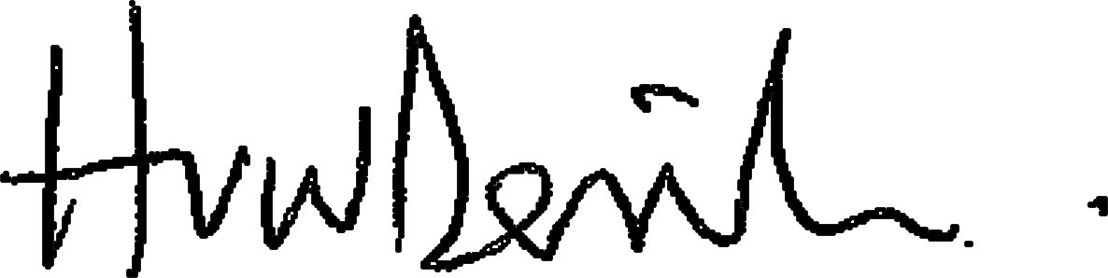 Principal Date: 10th June 2019

Chair of Governors Date:

Appendix 1 – Current post holders and responsible Individuals

Date completed / reviewed: | 10th June 2019

Role | Name of responsible individual
Chair of Governors | Luke Bowers
Governor whose responsibility/specialty is  H&S | Tbc at next GB
Principal | Huw Derrick
Deputy/Deputies | Humayun Rashid
Academy Safety Officer | Laura Hyams
Person(s) responsible for estates and facilities | Laura Hyams (Facilities Director)  David Brackstone (Facilities Manager)
Person(s) with duties for fire safety (Fire  Marshalls) | Laura Hyams  David Brackstone  Terry Brown  Rob Agombar
Person(s) with duties for first aid  arrangements | Rachel Hill
Person(s) responsible for HR | Laura Hyams

Appendix 2 – H&S organisational arrangements (organogram)

Chair of Governors

Principal

Deputies and
managers

Senior Staff and
heads of
department

Staff

Academy Safety
Officer

Ormiston Academies Trust

Board of
Trustees

Ormiston Academies Trust Head Office

Governor
s

for H&S

Contractors

Health and Safety Policy ₁₀

